**CHAPTER 2**

**LITERATURE REVIEW**

**2.1 Project Review**

Review of Projects been performed to learn from previous experiences and apply that knowledge in future projects or phases. and decide if the project should continue to the next phase, if not then what will be our next step.

To determine the effectiveness and efficiency in the use of the enterprise

resources supporting the project. and keep the project in the best of health.

Identify significant project problems on time and treat them appropriately.

**2.1.1** **Past** **Project Review**

**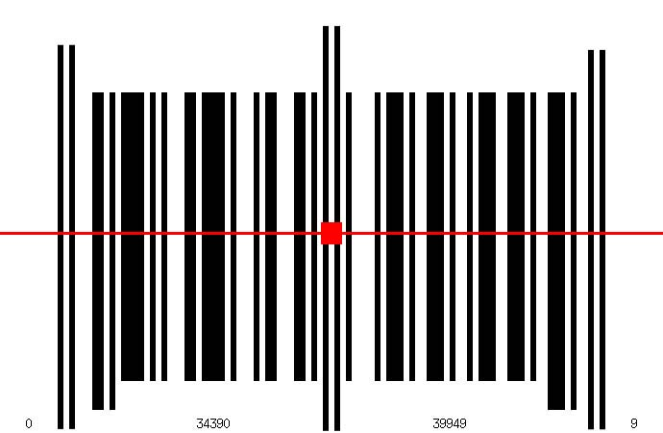** Many approaches was taken in past to build a barcode reader, they are working better to some extent, but not working very well after all, one of them is

"Recognition & Conversion of Barcode using camera Image

Gray threshold value is used to detect start and end of barcode called wavelet transform, to detect the center of the image the scan line approach is used By this approach the line at the center is consider to be taller in image and marked as center,



Draw back of this approach is that in an image most of the time there is no peak bars they all have in same length , So this approach is not practicle.

**2.1.2 Evaluation**

By evaluating scan line approach and other region based approaches observed that they work fine in some constraints, such as when image is clear, no discontinuity in the image and proper peak in the center bar,

**2.1.3 Conclusion**

After evaluation came to understand that an algorithm can be build that will work well in all of the circumstances better than previous algorithmand will work properly on most of the images on which the previous approaches can not function,

Chosen the intensity approach, and take the intensities of all of the bars in a fix axes and computed them works fine then other approaches.

**2.2 Barcode**

Barcode is an optical machine readable representation of data relating to the object to which it is attached.

Barcode is pre-defined/Systematic format of dark bars and white space.

It contains specific information.

It allows real time data to be collected accurately and rapidly.

Barcode may refer to as linear or one dimensional(1D). Later thy evolved in to rectangles, dots, hexagons & other geometric patterns in two dimensions (2D). Although 2D systems use a variety of symbols, they are also referred as barcode, discussed in types of barcodes.

**2.3 Why we use Barcodes**

**Speed of Entry**

It allows real-time data to be collected accurately.

Human. . .

½ second per character.

Barcode. . .

½ second per 10 characters.

**Accuracy of Data**

Human. . .

1 error per 250 Characters.

Barcode. . .

1 error per 3.5 million characters

**2.3.1 First Use of barcodes**

The first use of barcodes was to label railroad cars, but they were not commercially successful until they were used to automate super market  checkout systems, a task for which they have become almost universal. Their use has spread to many other tasks that are generically referred to as automatic identification and data capture (AIDC).

**2.4 Different Types of Barcodes**

Mainly barcodes are of three types.

* + 1. **Numeric only Barcode**

UPC-A & EAN are most widly uses numeric barcodes. They only can store information in numerical form.

* + - 1. **UPC-A** (Universal Product Code) on almost all retail product.

The Universal Product Code (UPC) barcode is used in the retail industry. UPC-A consists of 12 numbers.

C:\Users\Usman\Downloads\UPCa.gif

It can be seen on all retail products.

* + - 1. **EAN-13** (European Article Numbering)

International retail product. The European Article Numbering System (EAN) is a superset of U.P.C. EAN-13 consists of 13 numbers.

C:\Users\Usman\Downloads\ean13.gif

* + 1. **Alpha-Numeric Barcode**

They are used most of the time. They stores information in alphabatical plus numerical form.

* + - 1. **Code 128** World wide used.

**Character set A** allows for uppercase characters, punctuation, numbers and several special functions such as a return or tab.

C:\Users\Usman\Downloads\code128a.gifTypes of barcodes are :

CANADA POST  
ISBT 128  
USS Code 128  
ISS Code 128

**C:\Users\Usman\Downloads\code128b.gif Character set B** allows for upper and lower case letters, punctuation, numbers and a few select functions.

* + - 1. **Code 39(General Purpose)**

C:\Users\Usman\Downloads\code39.gifThe Code 39 barcode is the easiest to use of alpha-numeric barcodes and is designed for character self-checking, thus eliminating the requirement for check character calculations.

* + 1. **2 Dimensional Barcode**

Information is stored in a 2-Dimensional Image, It can also contain more information then 1-Dimensional barcode.

**2.4.3.1 DataMatrix:**

Can hold large amounts of data, especially suited for making very small codes.

It can encode letters, numbers, text and actual bytes of data; it can encode just about anything including extended characters, unicode characters and photos.

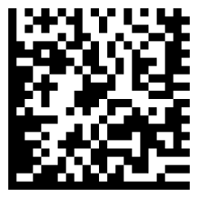

**2.4.3.2 QR (Quick Response)**

QR-Code is a very efficient, two-dimensional (2D) barcode symbology that encodes characters, numbers, text and actual bytes of data, including Unicode characters and photos.



**2.4.3.3 PPDF417:**

Excellent for encoding large amounts of data.

Large amounts of text and data can be stored securely and inexpensively when using the PDF-417 symbology. Using Reed Solomon error correction, the printed PDF417 barcode symbol can withstand damage without causing loss of data.

C:\Users\Usman\Downloads\PDF417_Barcode_Font.jpeg

**2.4.3.4 Maxicode:**

Fixed length, used by United Parcel Service for automated package sorting.

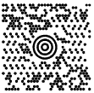

* + 1. **Industry Standard for Barcodes & Labels.**

Some of the mostly Industrial used barcodes are mentioned, There fox constraints are followed in industry.

**2.4.4.1 Bookland EAN 13**

Bookland EAN-13 (European Article Number) bar code has become a requirement in the book publishing industry. Bookland EAN-13 bar codes are used to represent the ISBN (International Standard Book Number) of the publication. Bookland EAN-13 bar codes begin with "978" followed by the first nine digits of the ISBN. The last character is a check digit.

**2.4.4.2 ISSN(International Standard Serial Numbering)**

An International Standard Serial Number (ISSN) is a unique eight-digit number used to identify a print or electronic periodical publication Periodicals published in both print and electronic form may have two ISSNs

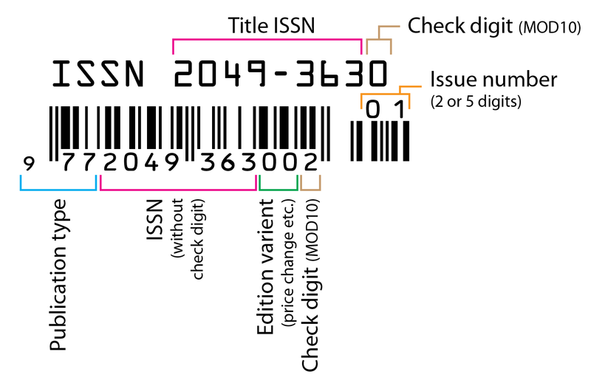

**2.5 Image Processing.**

Image Processing is any form of signal processing for which input is an image, such as photograph or video frame; the output of image processing may be either an image or a set of characteristics or parameter related to image.

Image processing is referred to processing of a 2D picture by a computer.

An image may be considered to contain sub-images sometimes referred to as regions-of-interest. This concept reflects the fact that images frequently contain collection of objects each of which can be the basis for a region. Thus one part of an image (region) might be processed to suppress motion blur while another part might be processed to improve color rendition. Sequence of image processing.

The most requirements for image processing of images is that the images be available in digitized form, that is, arrays of finite length binary words. For digitization, the given Image is sampled on a discrete grid and each sample or pixel is quantized using a finite number of bits. The digitized image is processed by a computer. To display a digital image, it is first converted into analog signal, which is scanned onto a display.

Before going to processing an image, it is converted into a digital form. Digitization includes sampling of image and quantization of sampled values. After converting the image into bit information, processing is performed. This processing technique may be, Image enhancement, Image reconstruction, and Image compression

**2.5.1 Image enhancement:**

It refers to accentuation, or sharpening, of image features such as boundaries, or contrast to make a graphic display more useful for display & analysis. This process does not increase the inherent information content in data. It includes gray level & contrast manipulation, noise reduction, edge crispening and sharpening, filtering, interpolation and magnification, pseudo coloring, and so on.

**2.5.2 Image restoration:**

It is concerned with filtering the observed image to minimize the effect of degradations. Effectiveness of image restoration depends on the extent and accuracy of the knowledge of degradation process as well as on filter design. Image restoration differs from image enhancement in that the latter is concerned with more extraction or accentuation of image features.

**2.5.3 Image compression:**

It is concerned with minimizing the number of bits required to represent an image. Application of compression are in broadcast TV, remote sensing via satellite, military communication via aircraft, radar, teleconferencing, facsimile transmission, for educational & business documents , medical images that arise in computer tomography, magnetic resonance imaging and digital radiology, motion , pictures ,satellite images, weather maps, geological surveys and so on.

**2.6 MATLAB Advantages.**

MATLAB is a general purpose programming language. When it is used to process images one generally writes function files, or script files to perform the operations. These files form a formal record of the processing used and ensures that the final results can be tested.

The ability to process both still images and video.

### 2.6.1 Access to implementation details

MATLAB provides many functions for image processing and other tasks. Most of these functions are written in the MATLAB language and are publicly readable as plain text files. Thus the implementation details of these functions are accessible and open to scrutiny.

Another advantage of MATLAB is that it allows one to ensure maximal numerical precision in the final result.

In general, image files store data to 8 bit precision. This corresponds to a range of integer values from 0-255. A pixel in a colour image may be represented by three 8 bit numbers, each representing the red, green and blue components as an integer value between 0 and 255. Typically this is ample precision for representing normal images.

However as soon as one reads this image data into memory and starts to process it it is very easy to generate values that lie outside the range 0-255. For example, to double the contrast of an image one multiplies the intensity values by 2. An image value of 200 will become 400 and numerical overflow will result. How this is dealt with will vary between image processing programs. Some may truncate the results to an integer in the range 0-255, others may perform the mathematical operations in floating point arithmetic and then rescale the final results to an integer in the range 0-255.

### 2.6.2 Advanced algorithms

MATLAB is a scientific programming language and provides strong mathematical and numerical support for the implementation of advanced algorithms. It is for this reason that MATLAB is widely used by the image processing and computer vision community. New algorithms are very likely to be implemented first in MATLAB, indeed they may only be available in MATLAB.

## 2.6.3 Conclusion

MATLAB may not be as user friendly as an application like Photoshop, however, being a general purpose programming language it provides many important advantages for image processing.

* It ensures the image processing steps used are completely documented, and hence can be replicated.
* In general, the source code for all image processing functions are accessible for scrutiny and test.
* It allows one to ensure numerical precision is maintained all the way through the enhancement process.
* Image processing algorithms available under MATLAB are likely to be more advanced than those available from other image processing applications.
* Thus our algorithm can be easy implemented using matlab.